Bugs 5, 6 and 7 Investigation

Legend: **blue** words are classes, **green** words are methods, and **purple** words are instance variables. (If a word is not coloured, that means it is being used in its natural English sense).

# Description

# Static Review

## Bug 7

If we take bugs 5 and 6 at face value, without any testing, and assume that the game really does never roll or guess spades, this leads to an explanation for bug 7 (which is why they are placed together in the first place).

We can calculate the odds of winning in a game with no bugs, and not just take the 42% given in the initial bug report at face value. Then, we can calculate the odds of winning with the spades removed from the game and see if it is anywhere near the 48.8% found by testing.

### Calculating the odds

Let’s say the number of possible faces is ‘n’.

There are $n^{3}$ possible ways to roll the dice (first roll has n possibilities, second roll has n possibilities, third roll has n possibilities). There is a $\frac{(n-1)^{3}}{n^{3}}$ chance of losing (if you pick a particular symbol, the dice now has n-1 ways to come up that doesn’t match your chosen symbol, and there are three rolls).

So therefore there is a

$$1-\frac{(n-1)^{3}}{n^{3}}=\frac{n^{3}-(n-1)^{3}}{n^{3}}$$

chance to win, and the winning percentage should be

$$\frac{100(n^{3}-(n-1)^{3})}{n^{3}}$$

Let’s try this with n = 6 and see if we get 42.0%.

29ncee of losing get 42.0%.nninre are three rolls).ice now has n-1 ways to come up that doesn;t

This looks pretty good. The initial bug report reported it as 42% but it could have been rounding.

Now let’s try with n = 5 (all the faces without spades).

29ncee of losing get 42.0%.nninre are three rolls).ice now has n-1 ways to come up that doesn;t

Wow, 48.8% exactly! Would be a pretty huge coincidence if it wasn’t caused by the missing spades. But we will of course do plenty of testing. And we will test this bug again when we have solutions for bugs 5 and 6, to see if the winning percentage changed to 42.1%.

## Bugs 5 and 6

Since these bugs are about what can be rolled, it makes sense to start with where the dice are rolled for each game (for bug 5 – spades never being rolled) and where the player choses the pick (for bug 6 – player never chooses spades).

If we have a look at main we can see that the actual game happens inside Game’s playRound:

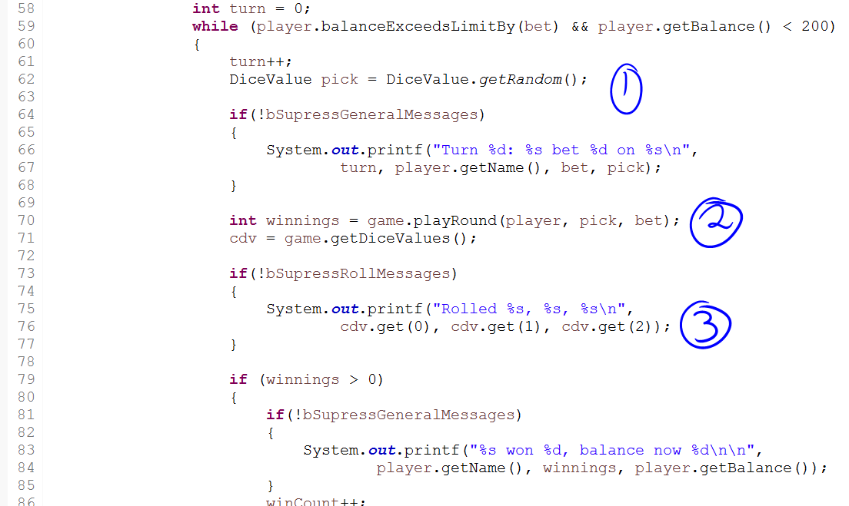

At (1), the player picks the face they wish to bet on (we will come back to this for bug 6), at (3) the rolls are being displayed, so therefore the rolls and such must be determined during (2) (which is Game’s playRound).

Now let’s look at playRound and try to determine when the dice are rolled to get new values:

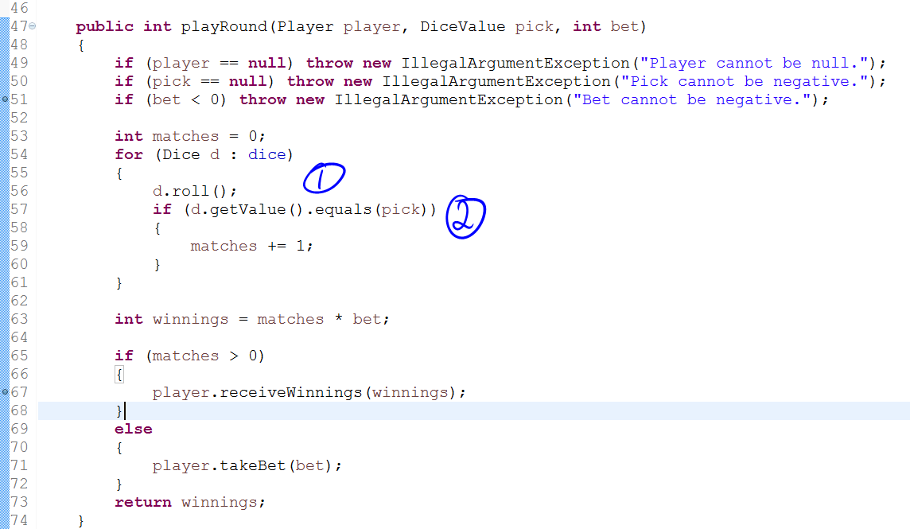

At (1), it looks like the dice are being rolled (because of the helpful method name). But at (2), the values of the dice are being compared against the pick, so we can be fairly sure the dice really did get rolled at (1) (otherwise they’d be being compared to the old values).

So let’s have a look inside roll.

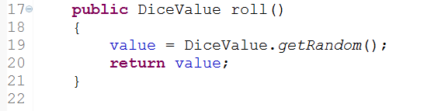

So DiceValue’s getRandom is being called and the result is being set to value (which would be what Dice’s getValue will return). Let’s have a look at getRandom now.

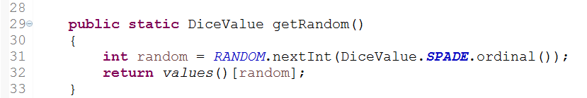

According to <http://crunchify.com/why-and-for-what-should-i-use-enum-java-enum-examples/>:



So on line 32, we are retrieving the enum value according to its index. And our enum values are:

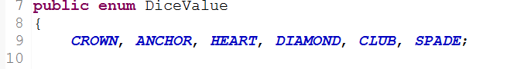

So CROWN will be 0, ANCHOR 1, etc.

And ‘random’ is this index. Now let’s see how random is determined.

First of all the RANDOM variable is defined as:



So let’s see what Random.nextInt does.

According to <https://www.tutorialspoint.com/java/util/random_nextint_inc_exc.htm>:

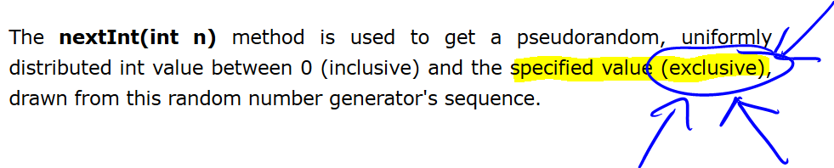

Random.nextInt(n) will get a random number between 0 and **less than** n (as highlighted above – exclusive of n). So this means our getRandom method must be getting all the ordinal values not including spades (as it is the last one).

This explains bug 5 perfectly. The roll method called DiceValue’s getRandom, and getRandom can return any DiceValue except for spades.

Now back to bug 6. As we noted earlier, the pick came from point (1) in the screen snip of main where we had the line:



Through investigating bug 5, we found that roll called DiceValue’s getRandom, which infected Dice’s value (which is of the class DiceValue). Here, DiceValue’s getRandom is being called directly and the result placed in pick. We already know that getRandom infects the value it returns, so we can see it infects pick (so our initial hypothesis that bugs 5, 6, and 7 are related is holding up so far).

Here are our hypotheses:

1. getRandom can’t ever return spades
2. Bugs 5 and 6 are caused by the same programming error
3. Bug 7 is caused by the same programming error as bugs 5 and 6

# Hypothesis testing

## Hypothesis 1

To test this one, we will make a little debug section in the getRandom method that will trigger if the method would ever return spades. Then, if this section does get triggered, we know it is not getRandom’s fault and there is another problem somewhere else in the code where the spades are getting lost. If, however, this section is never triggered, then we know that getRandom really cannot produce spades.

We will start off by triggering when we get clubs, to make sure the trigger point actually works (just in case we do something wrong and it can never be triggered, and then we blame getRandom unnecessarily).

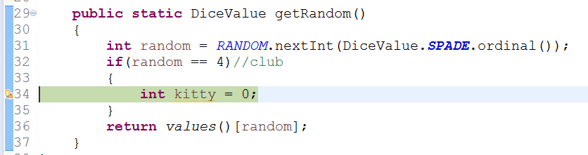

(There is actually a breakpoint there – Eclipse has a silly design where it puts warnings over the top of your breakpoints.) We can see the debug section does get triggered when we hit a club.

If we step through a bit further we see the clubs be printed:

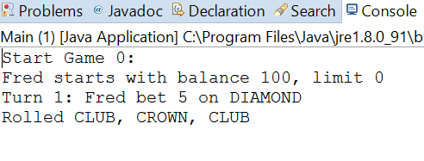

So now we replace the 4 with a 5 (for spades – it is the 6th enum value and so has an ordinal value of 5) and see if our breakpoint gets triggered.

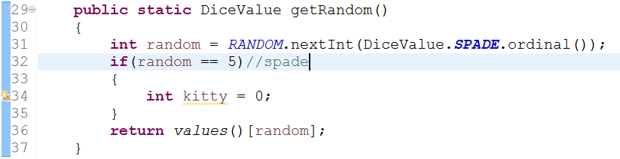

(Again, there is actually a breakpoint there but you can’t see it.) Nope – the breakpoint does not get triggered! Therefore, we have verified that getRandom cannot return spades as an answer.

## Hypothesis 2

Through the static review we determined that both Dice’s roll (which is the beginning of the sequence that leads to bug 5 being expressed) and DiceValue’s getRandom (which is the beginning of bug 6 being expressed) both end up at DiceValue’s getRandom, which is a common method. Through verifying hypothesis 1 (see above) we have shown that getRandom causes an infection in the DiceValue that it returns, so we can conclude that both bug 5 and bug 6 are caused by the same error.

## Hypothesis 3

We can’t really test this one directly. We have to wait until we have implemented a solution, then retest with Bug7Replication.java to determine if the odds have changed.